Takneek Auto Quiz:  
  
Top 2 teams from each pool qualify for finals.  
Participation restricted to Y11 & Y12 junta only.   
  
Prelims: 20 questions  
  
Mains: 5 rounds  
Round 1: Infinite bounce, passing round:  
10 points for a direct question, 10 points on the pass, no negatives

Round 2: Visual Connect 1  
Round 3: Take your pick  
Round 4: Visual Connect 2  
Round 5: Infinite pounce, passing round   
10 points for a direct question, 10 points on the pass. Unique about this round is that all teams get to bid for every question. Bid would be open for a specific time period. +15 for getting the correct answer on the pounce and -10 for getting it wrong. No negatives if the team does not pounce.

One of the above mentioned rounds can be exchanged for a technical round.

**CONTACTS:**

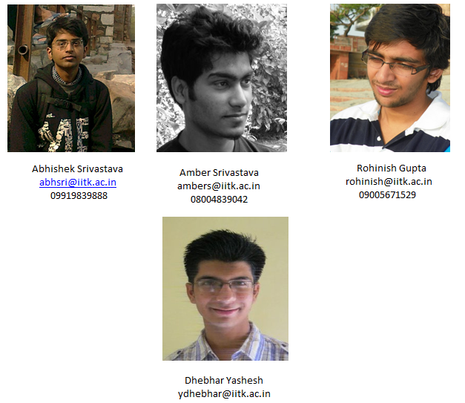

09559434185